BOX PLOT
The given box plot represents the distribution of SSC percentage (ssc_p) based on board of education (ssc_b) and gender.
Each box in the plot shows the quartiles (Q1, Q2, Q3) of the data:
- Q1 (First Quartile) → The lower edge of the box (25% of data lies below this value)
- Q2 (Median) → The line inside the box (middle value of the data)
- Q3 (Third Quartile) → The upper edge of the box (75% of data lies below this value)
The difference between Q3 and Q1 is called the Interquartile Range (IQR), which shows the spread of the middle 50% of the data.

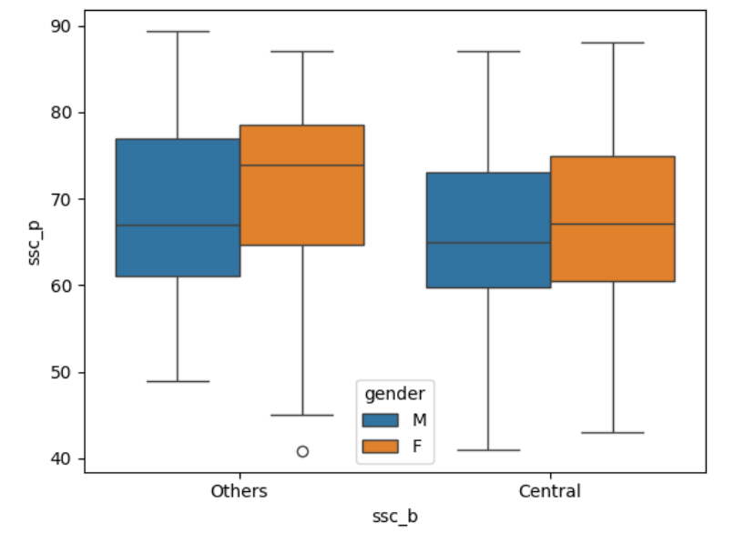

From the graph, we can see that students from both Central and Other boards have almost similar SSC marks. However, students from the Other board have a slightly higher median score than those from the Central board.
When we compare gender, female students (F) have higher median SSC marks than male students (M) in both boards. This shows that female students performed a little better overall.
The spread of the data (shown by the box and whiskers) shows that marks are spread across a wide range in all groups. There are also a few low values which can be considered as outliers.
Overall, the graph helps us understand how SSC marks change based on board of education and gender, with small differences in performance and distribution.

VIOLIN PLOT
- This graph is a violin plot that shows how salary is distributed based on specialisation (Mkt&HR and Mkt&Fin) and gender.
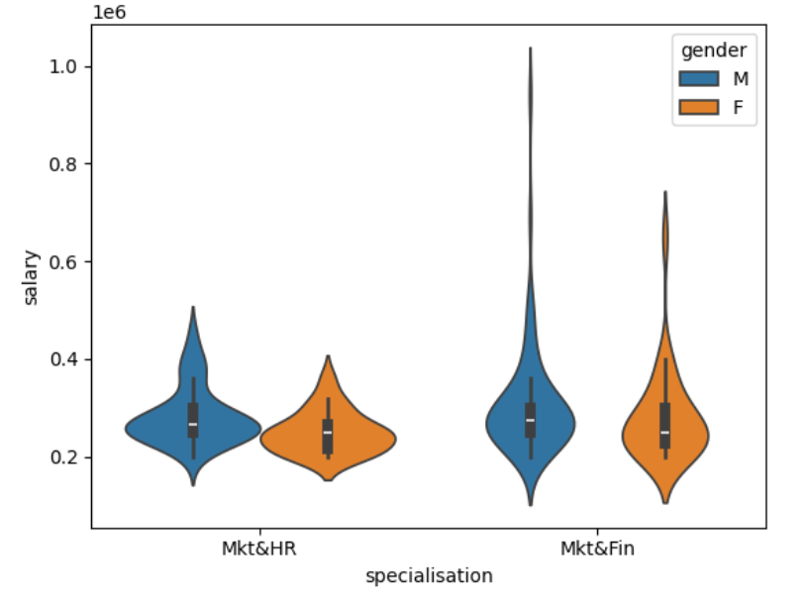
From the graph, we can see that students in both Mkt&HR and Mkt&Fin specialisations receive salaries mostly in a similar range, but there are some differences in how the salaries are spread.
In Mkt&Fin, the salary range is wider, especially for male students, showing that some students receive very high salaries. This means there is more variation in salaries in Mkt&Fin compared to Mkt&HR.
When we compare gender, male students (M) generally have slightly higher salary distributions than female students (F) in both specialisations. However, the difference is not very large, and both genders have overlapping salary ranges.
In Mkt&HR, salaries are more concentrated around a smaller range, meaning most students get similar salary packages.
Overall, this graph helps us understand how salary varies with specialisation and gender, showing that Mkt&Fin offers a wider range of salaries and slightly higher opportunities for higher pay.

- This graph shows how pulse rate changes based on time (1 min, 15 min, 30 min), type of activity (rest, walking, running), and diet (no fat and low fat).

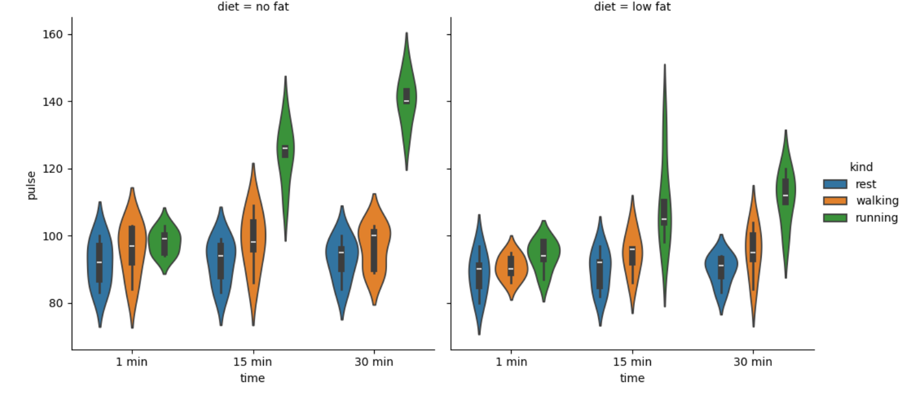
From the graph, we can clearly see that pulse rate increases as the activity level increases. During rest, the pulse rate is the lowest. It increases during walking and is highest during running.
As time increases from 1 minute to 30 minutes, the pulse rate also generally increases, especially for running, showing that longer activity leads to a higher heart rate.
When comparing diets, both no fat and low fat show a similar pattern. However, in some cases, the no fat diet shows slightly higher pulse rates during intense activities like running.
The spread of the data is wider for running, which means there is more variation in pulse rates during high activity. For rest, the values are more closely grouped, showing less variation.
Overall, the graph helps us understand that pulse rate depends on activity type, duration, and slightly on diet, with activity having the strongest effect.

